KARANAM YESWANTH TEJA

289224

**BASH PROJECT**

1. **Bash Case**

**1.1)**

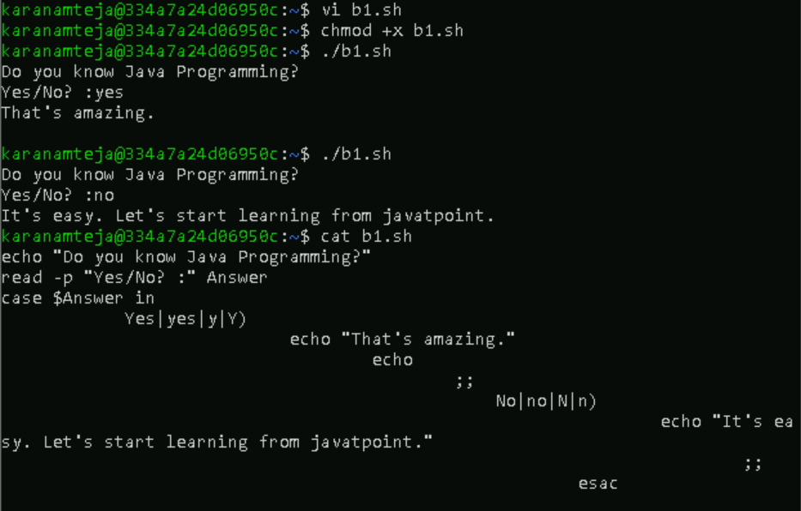

**1.2)**

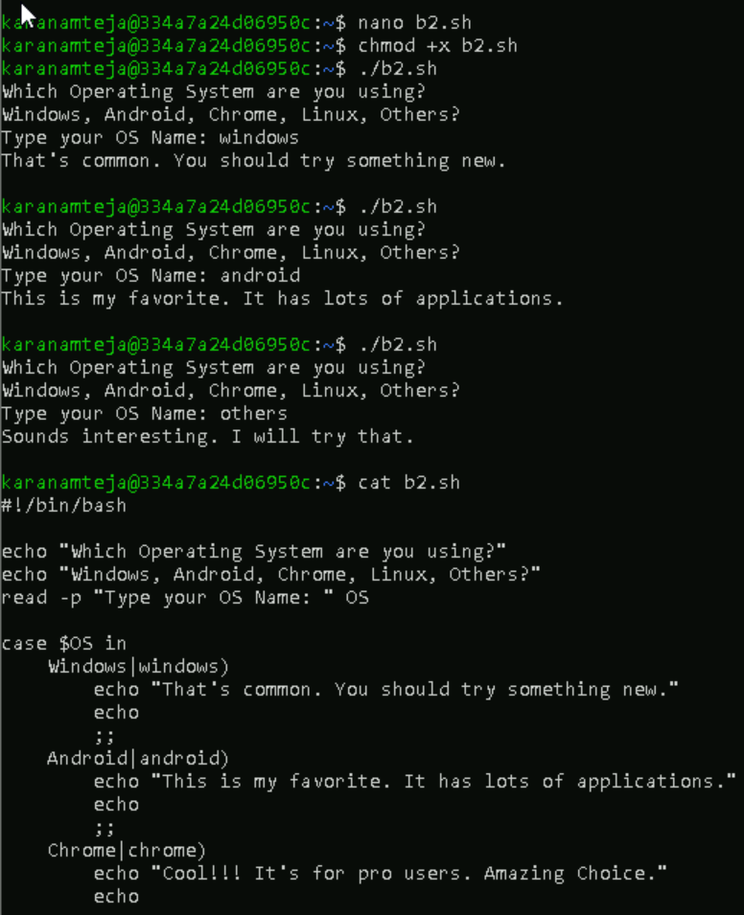

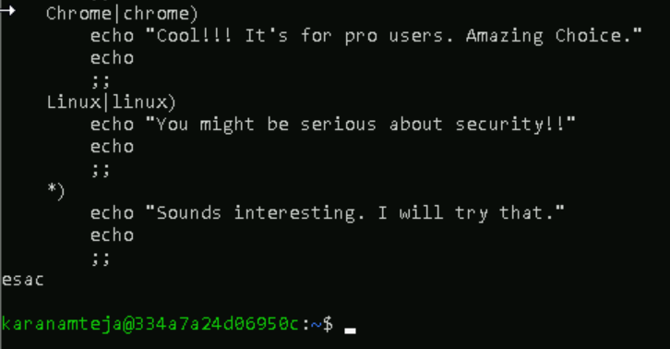

1. **For loop**

**2.1)**

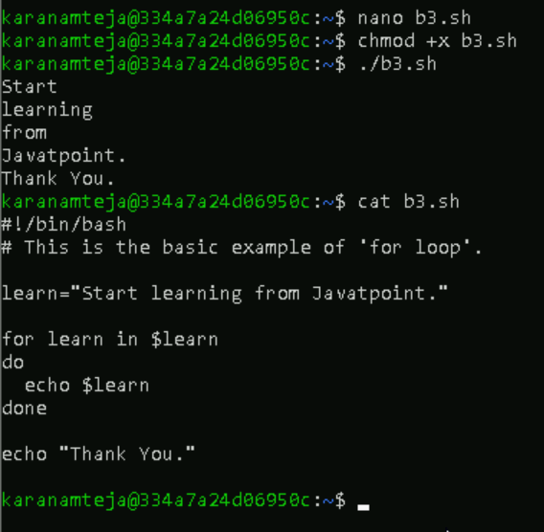

**2.2) For loop to read a range**

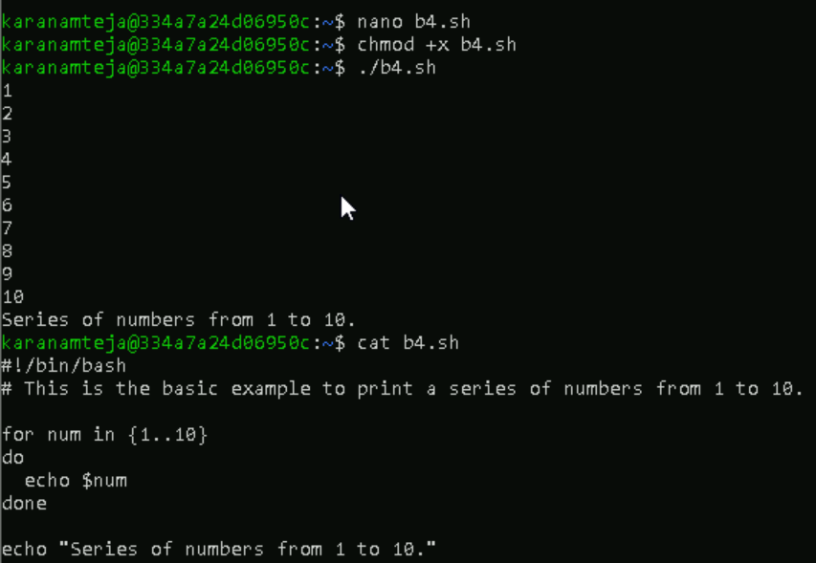

**2.3) For Increment**

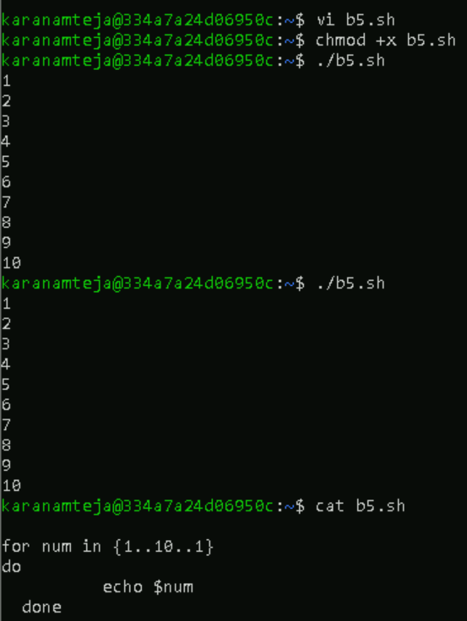

**2.4) For Decrement**

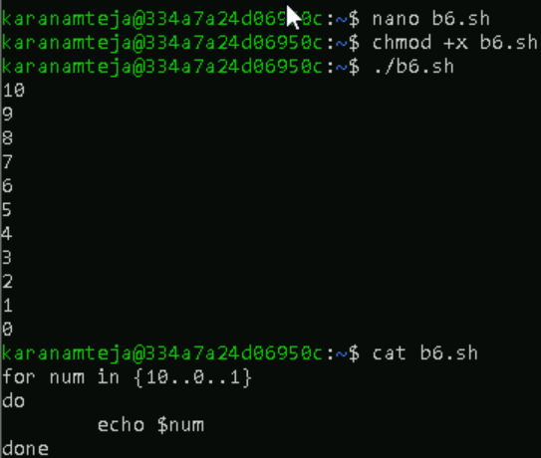

**2.5) For loop to read array variables**

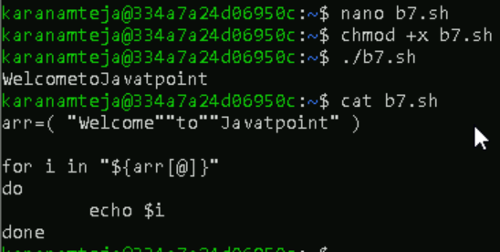

1. **While loop**

**3.1) While Loop with single condition**

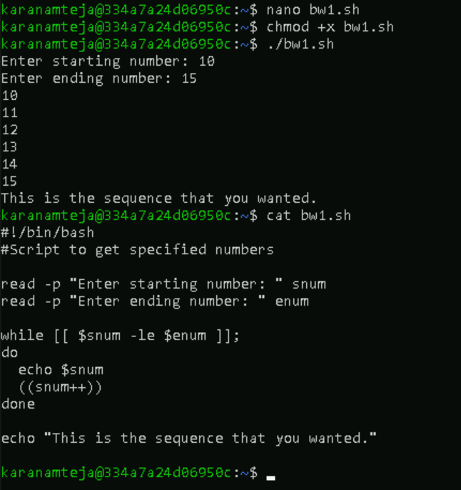

**3.2) While Loop with multiple conditions.**

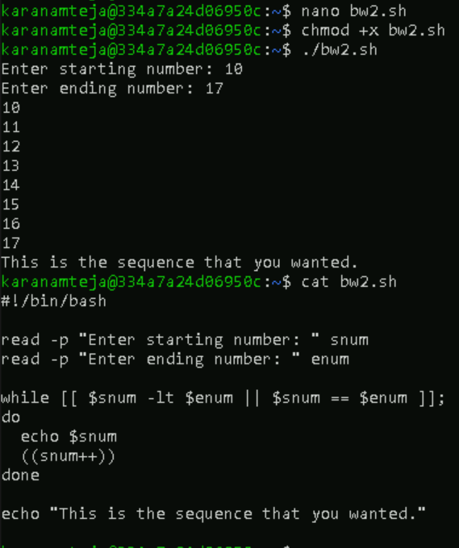

**3.3) Infinite while loop**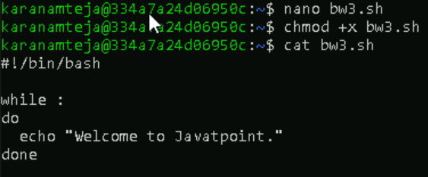



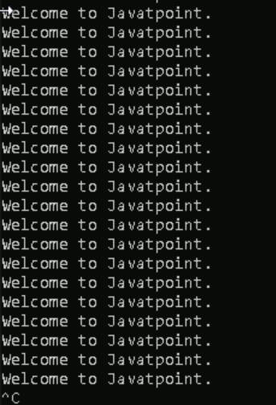

**3.4) While loop with break statement**

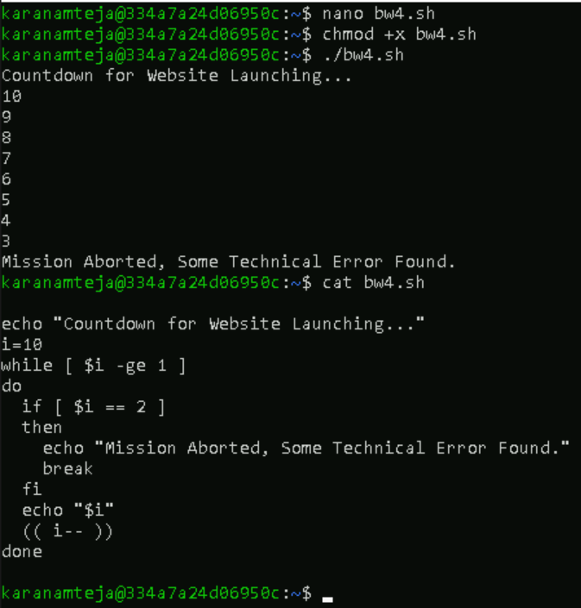

**3.5) While loop with continue statement**

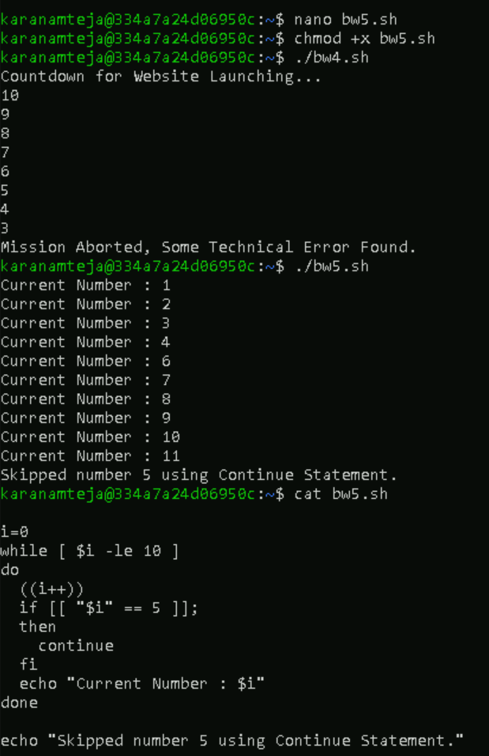

**3.6) While Loop with C-style**

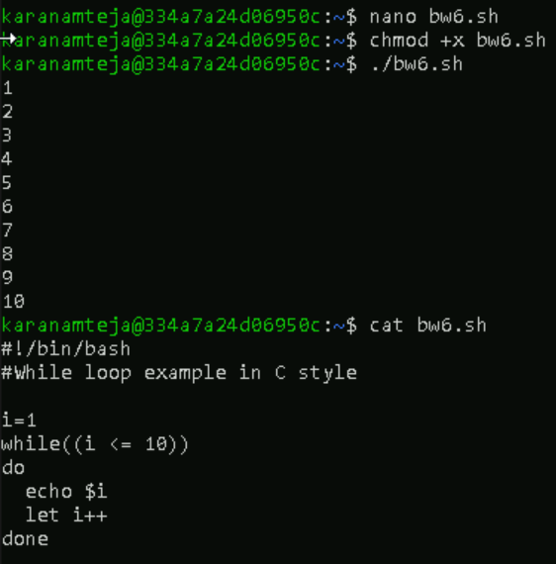

1. **BASH UNTIL LOOP**

**4.1) Until loop with single condition**

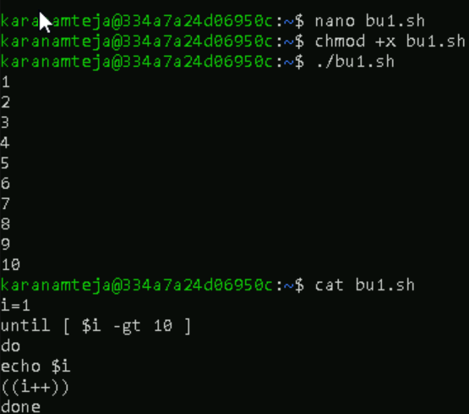

**4.2) Until loop with multiple condition**

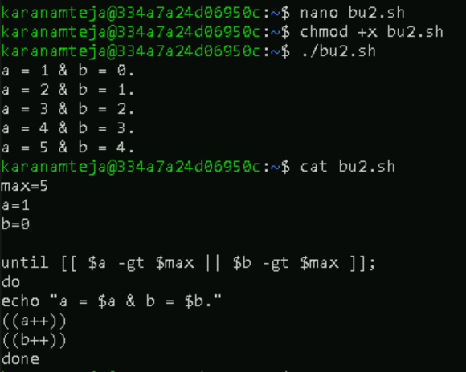

1. **Bash String**

**5.1) Equal operator**

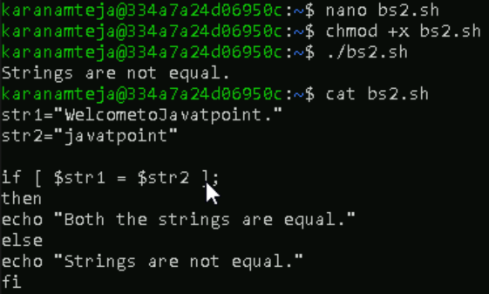

**5.2) Not equal operator**

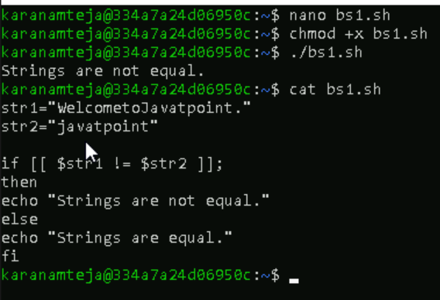

**5.3) Less than operator**

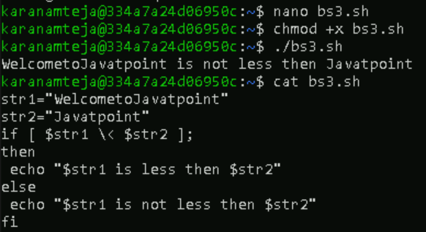

**5.4) Greater than operator**

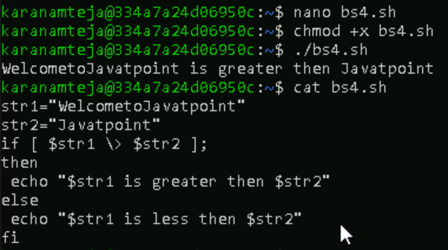

**5.5) To check if the string length is greater than zero**

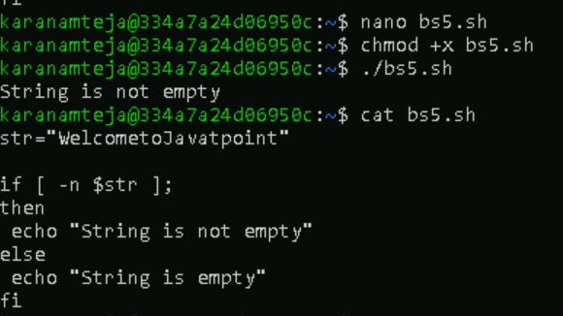

**5.6) To check if the string length is equal to zero**

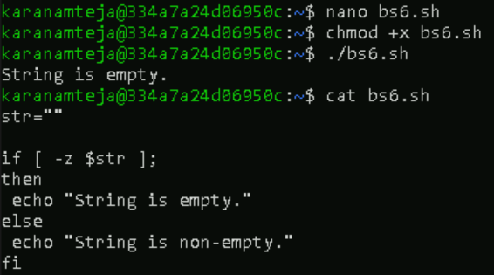

1. **Bash Find**

**6.1) Find string length in bash - $[#str]**

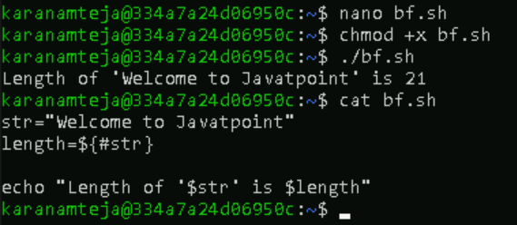

**6.2) find string length in bash – expr**

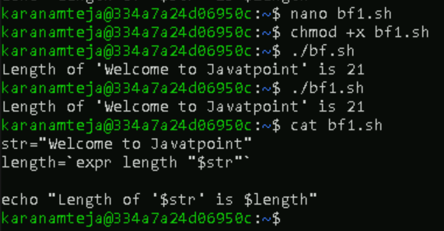

**6.3) find string length in bash – expr**

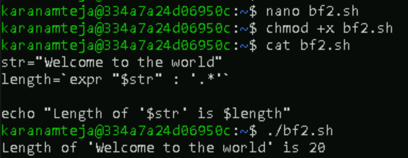

**6.4) find string length in bash – wc**

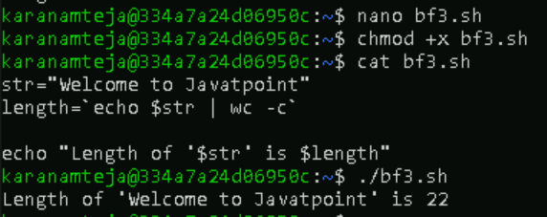

**6.5) find string length in bash - awk**

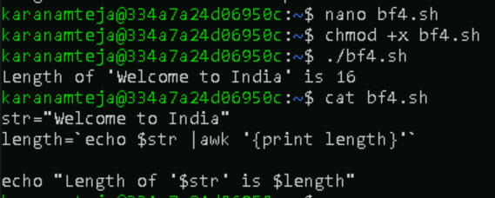

1. **Bash Split String**

**7.1) By Space**

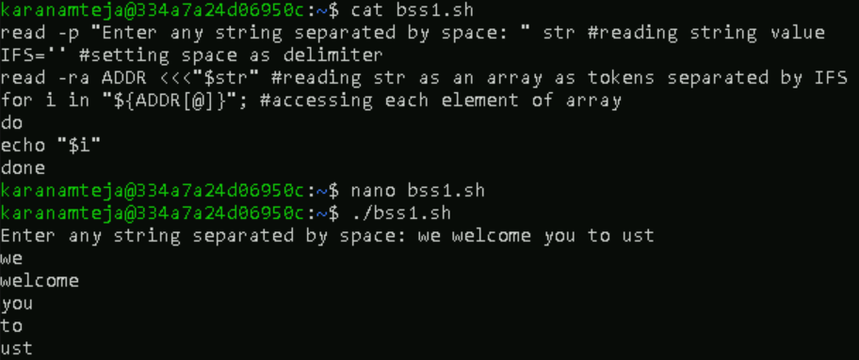

**7.2) By Symbol**

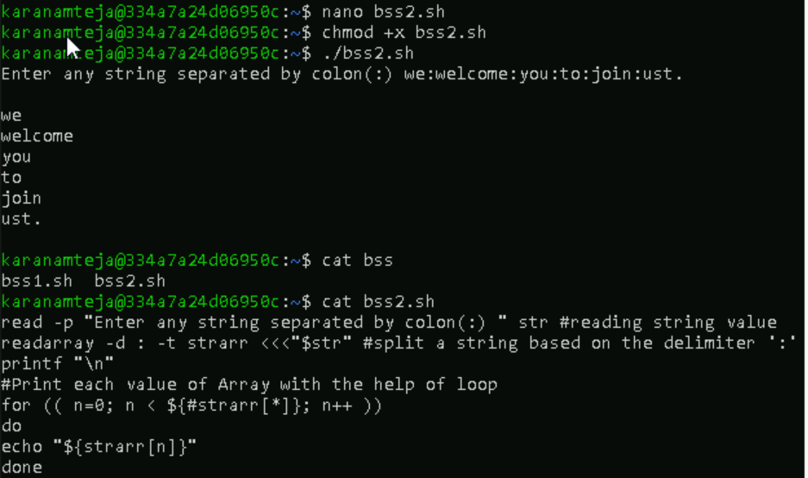

**7.3) by another string**

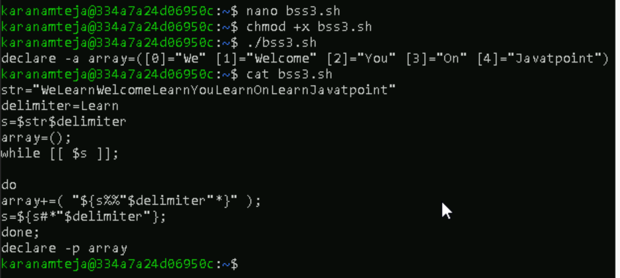

**7.4) by trim command**

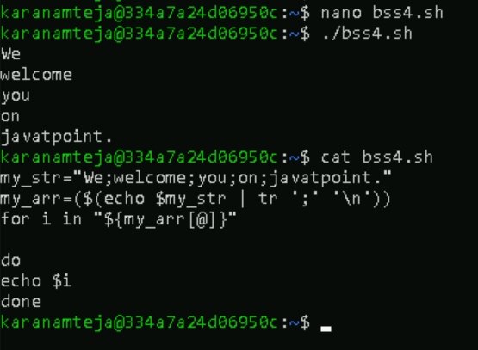

1. **Bash Substring**

**8.1) To extract till specific characters from starting**

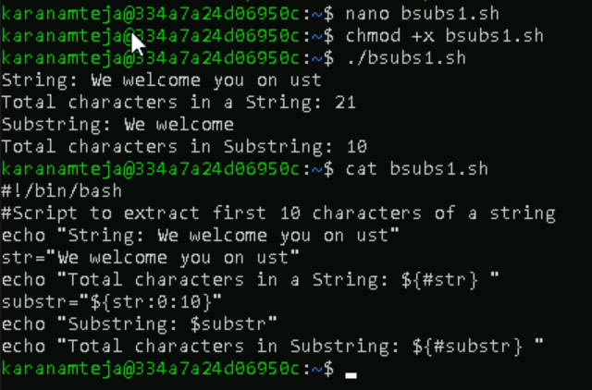

**8.2) To extract from specific characters onwards**

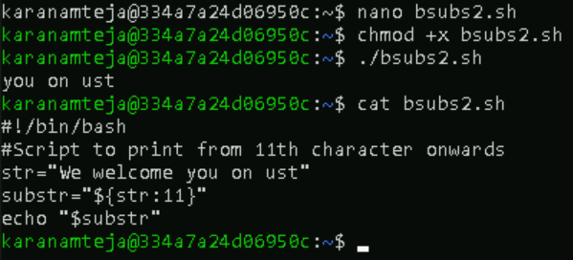

**8.3) To extract a single character**

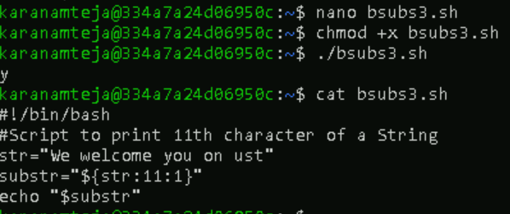

**8.4) To extract the specific characters from last**

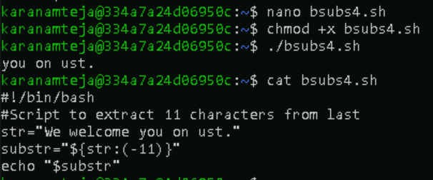

1. **Bash concatenate String**

**9.1) Write variables side by side**

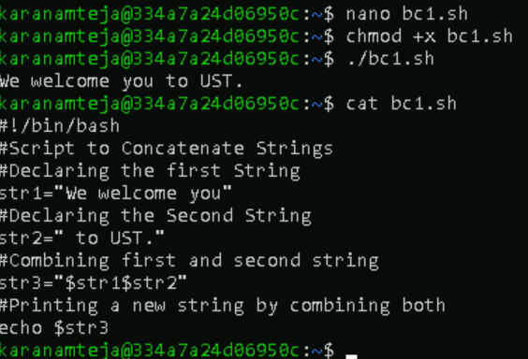

**9.2) Using Double Quotes**

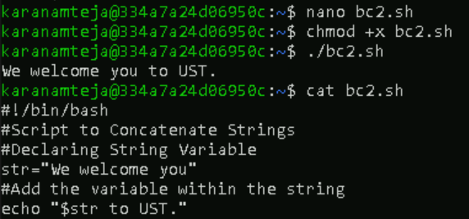

**9.3) Using append operaor with loop**

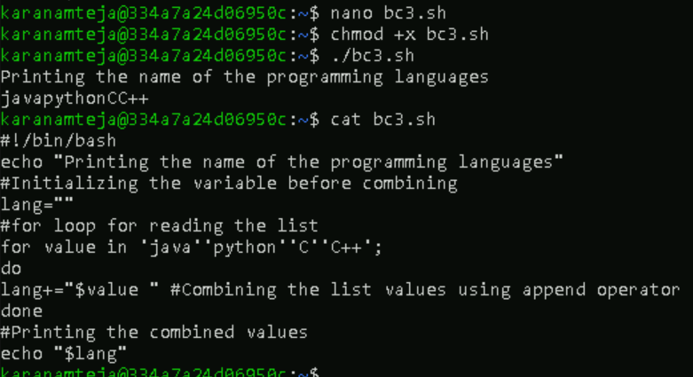

**9.4) Using the printf function**

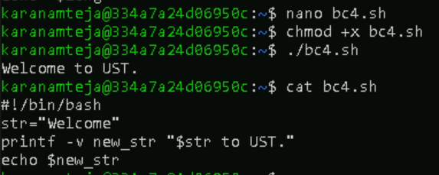

**9.5) Using Literal Strings**

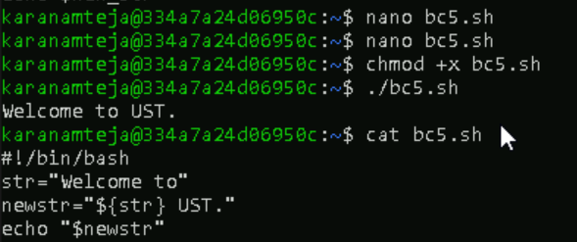

**9.6) Using Underscore**

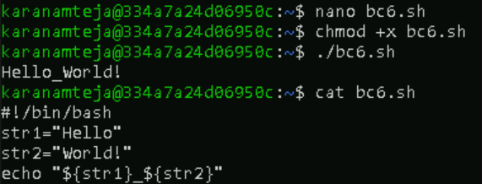

**9.7) Using any Character**

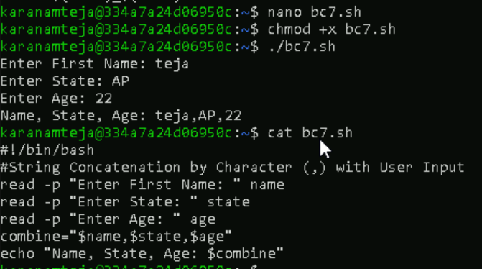

1. **Bash Functions**

**10.1) Syntax**

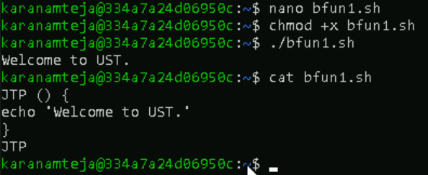

**10.2) Passing Arguments**

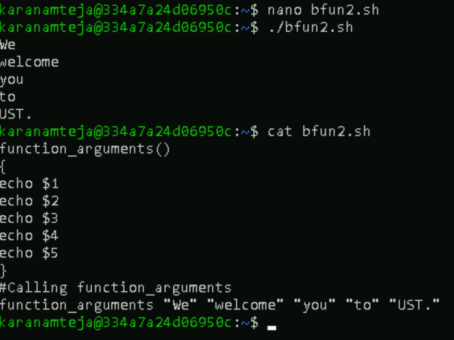

**10.3) Variable Scope**

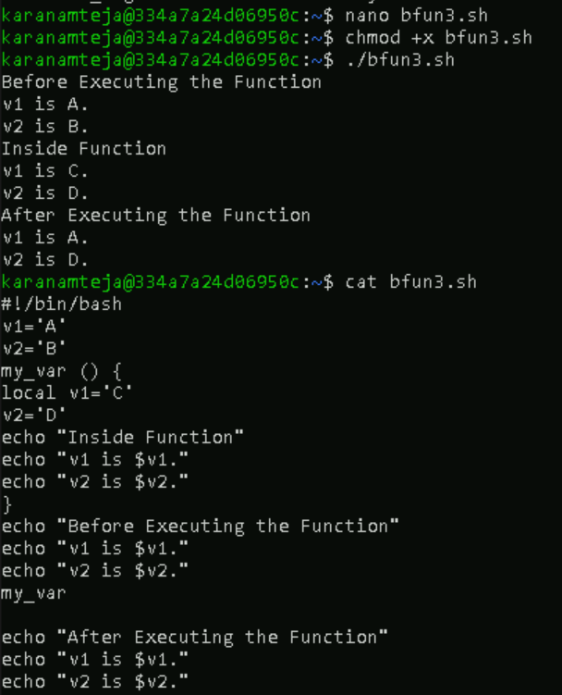

**10.4) Return Values**

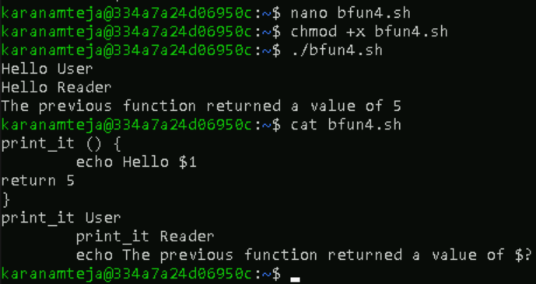

**10.5) Overriding Commands**

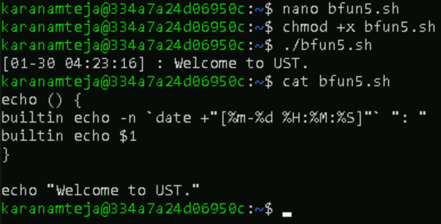

1. **Bash Array**

